## Human Long Term Memory:

### Characteristic

Contains mainly information that has been reinforced and will most likely never be forgotten.

### Guideline

Relate icons and current design with long-term memory to provide easier use and adoption.

### Example



The trash can/recycle bin is something that people have seen/used for many years so it is intuitive what to do with it.

## Automatic Processing:

### Characteristic

Actions that the user should find fast, easy, and require minimal effort

### Guideline

Provide clear information to the user via design that reduces the need to think about other actions

### Example

## Image result for download icon

The arrow going down into a file holder is a symbol that without thinking, people will assume that it goes into a folder for something

## Affect/Emotion:

### Characteristic

Responding to, and eliciting emotions from the user.

### Guideline

Be careful when designing to focus on eliciting only the emotions from the user we want.

### Example

## Image result for pain chart with faces

Each level of pain corresponds to a face that is showing emotion a user can relate to.

## Social Interaction:

### Characteristic

People interacting, either digitally or physically.

### Guideline

Keep interactions simple, as fluid as possible

### Example



Chat bubbles like this shows two people having a conversation, which means that you’ll automatically be talking to someone else.

## Cultural Differences:

### Characteristic

This primarily relates to the differences that other cultures might have with the creators.

### Guideline

Examine the locale where the product will the distributed, and adjust accordingly.

### Example

## Image result for japanese yen symbol

Since that Japanese don’t use US Dollars as their currency it doesn’t make any sense to provide details on pricing in USD, so automatically adjusting it to the current locations currency makes sense.

## Gestalt Laws of Perceptual Organization:

### Characteristic

A group of laws containing; proximity, continuity, similarity, and closure.

### Guideline

Display related items together. Also make like items similar, while unlike items dissimilar.

### Example

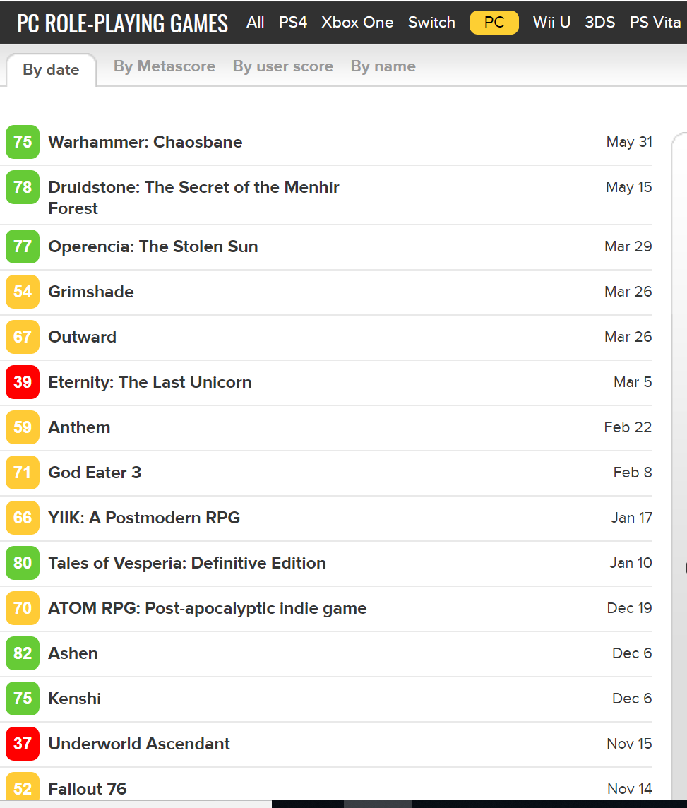

Here multiple RPG’s are grouped together, with various ways to sort them.